Factorization Batch Algorithm and Prime Numbers Distribution

Shaimaa said soltan¹

¹ Computer Engineer, Toronto, Canada

Correspondence: Shaimaa Soltan, 3050 Constitution Blvd, Mississauga, ON., L4Y 3X1, Canada. Tel: 1-647-801-6063 E-mail: shaimaasultan@hotmail.com

---------------------------------------------------------------------------------------------------------------------------------
Suggested Reviewers (Optional)

Please suggest 3-5 reviewers for this article. We may select reviewers from the list below in case we have no appropriate reviewers for this topic.

Name: | E-mail:

Affiliation:

Name: | E-mail:

Affiliation:

Name: | E-mail:

Affiliation:

Name: | E-mail:

Affiliation:

Name: | E-mail:

Affiliation:

Factorization Batch Algorithm and Prime Numbers Distribution

Abstract
This paper introduces a primary set for Natural numbers that represents the distribution of prime numbers. Using this primary set of Natural numbers, we are going to introduce batch algorithm to get a set of all prime numbers up until number N. and a batch factorization algorithm for its prime composites.

Keywords: Prime Number, Distribution

1. Introduction

  - Pyramid distribution.
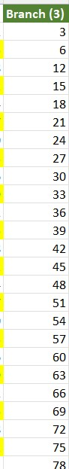
In previous paper we showed a pyramid distribution for all natural numbers², and one of the branches or sides of the pyramid was only for natural number 3 and its multipliers. Any number in this branch except natural number 3 for sure is not Prime.
Figure 1. Branch (3) have numbers that are divisible by natural number [3]

And the other two sides for the pyramid include the rest of all natural numbers.

One of the other two sides of the pyramid starts with natural number 1 (Branch (1)), increases with step = 3 (i.e., difference between numbers in this branch = 3)
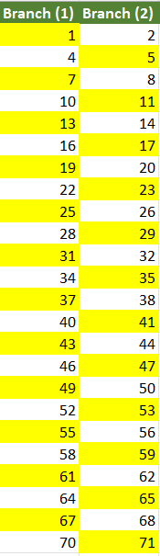
The other side starts with natural number 2 (Branch (2)) and increases with step = 3 (i.e., difference between numbers in this branch = 3)
Figure 2. Pyramid distribution Branch (1) and Branch (2) lists
These two sides or branches (Branch (1) and Branch (2)) include all the prime numbers and some other numbers.
As it shows in Figure 2. If we choose numbers only that are highlighted in yellow, we simply will be going to remove all even numbers from both branches.
By this step these two branches now do not have any number that can be divided by 2 or 3.

Now we need to remove any number that is divisible by 5 from these two Branches (Branch (1) and Branch (2)).
If we rearrange these two branches and only showed the numbers that are highlighted in Yellow
Then we will get a new filtered branch without any even number.

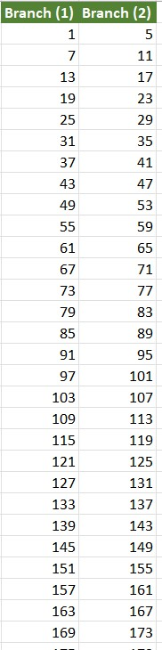
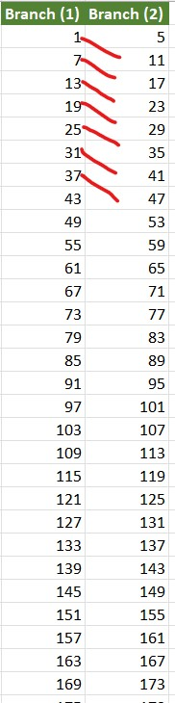
Figure 3. Branch (1) and Branch (2) after Filtered out even numbers.

Note (1): These two filter Branches, one starts at 1 with step = 6 and the other one starts at 5 and with step = 6 also.
Note (2): Branch (2) except natural number 5, Branch (2) have the same numbers in Branch (1) but increased by step = 10

Therefore, if we removed any number that is divisible by 5 from Branch (1) we will not going to have any number divisible by 5 in Brach (2) as well, because all numbers in branch (2) are the numbers in branch (1) + 10.

In order to remove all numbers that are divisible by 5. We know that Any number that ends by digit 5 will be divisible by 5.

Therefore, we can refilter Branch (1) to only numbers that ends in digits [1, 7, 3, 9].

Now the new Branch (1) will not be going to have any number that is divisible by 5. And there for Branch (2) will not going to have any number divisible by 5 as well as Branch (2) = Branch (1) +10.

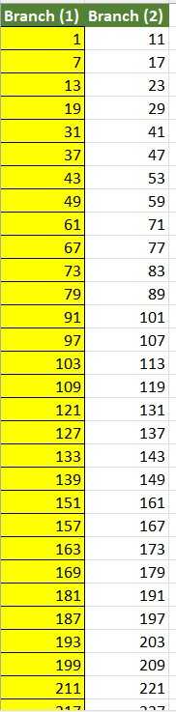
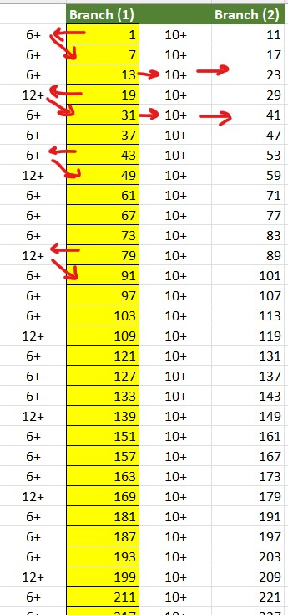
At this stage, by these simple steps we filtered Branch (1) to numbers not divisible by [ 2, 3, 5].
Figure 4. Branch (1) and Branch (2) after filter out [5]

Note (1): all number in Branch (1) ends in digits [1,7,3,9] in this order.
Note (2): all numbers in Branch (1) if ends in [1 ,7, 3] next number will be by adding 6.
Note (3): all numbers in branch (1) if ends in [9] next number will be by adding 12.
Note (4): all numbers in Branch (2) = 10 + Branch (1)
From these notes Branch (1) is the main Prime numbers distribution Branch.

And by this stage we can reconstruct Branch (1) easily by just these 4 Notes.
To elaborate more about statement “Branch (1) is the main Prime numbers distribution Branch”.
Let us see the results of finding the factors using divide by each number in the Branch. You will see in the next Figure how these numbers in branch (1) keeps shown at each factor.
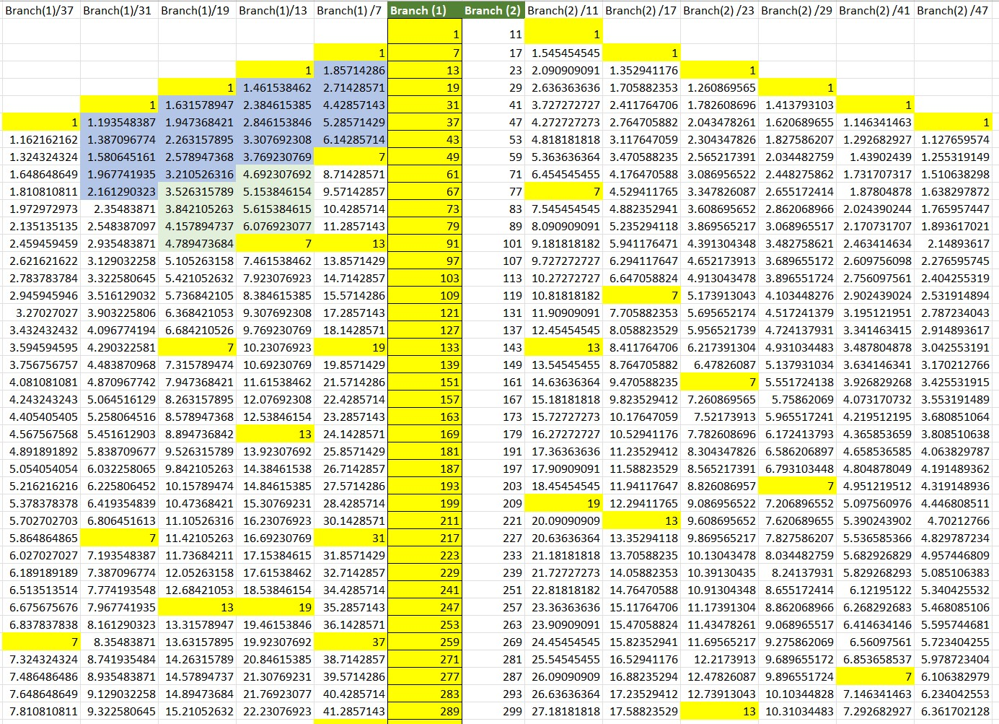
Figure 5. Primary List distributions.

As you see in the previous Figure Branch (1) numbers keeps shown in the distribution even if we are dividing by different number. We will get only natural numbers when we have Branch Factors.

To get only prime numbers from this Branches, we can use this method of dividing by each number in branch (1) and remove all numbers that give us natural numbers. And the list will be getting shorter each time to get closer to Prime numbers list.
Or we can use matrix.
If we add both Branches to our matrix ( data frame columns names and row index) we can construct a true false matrix that we can find from it all the factors for these numbers in branch (2) and branch (1). And also, if we filter the rows for rows that have only two true maximum we get our prime numbers list as well of course also [2,3,5] primes.

Also Note that numbers now ordered as two numbers ends with digit [1], one number ends with digit [1] and the numbers after it by 10. Then two numbers end with digit [7], one number end with digit [7] and the number after it by 10. Then two numbers end by digit [3] one number ends by digit [3] and the number after it by 10. Then two numbers end by digit [9] and the number after it by 10.
{1 ,11 , 7 , 17 , 13 , 23, 19 ,29 , 31 , 41, 37, 47 , 43 , 53, 49, 59, …..}

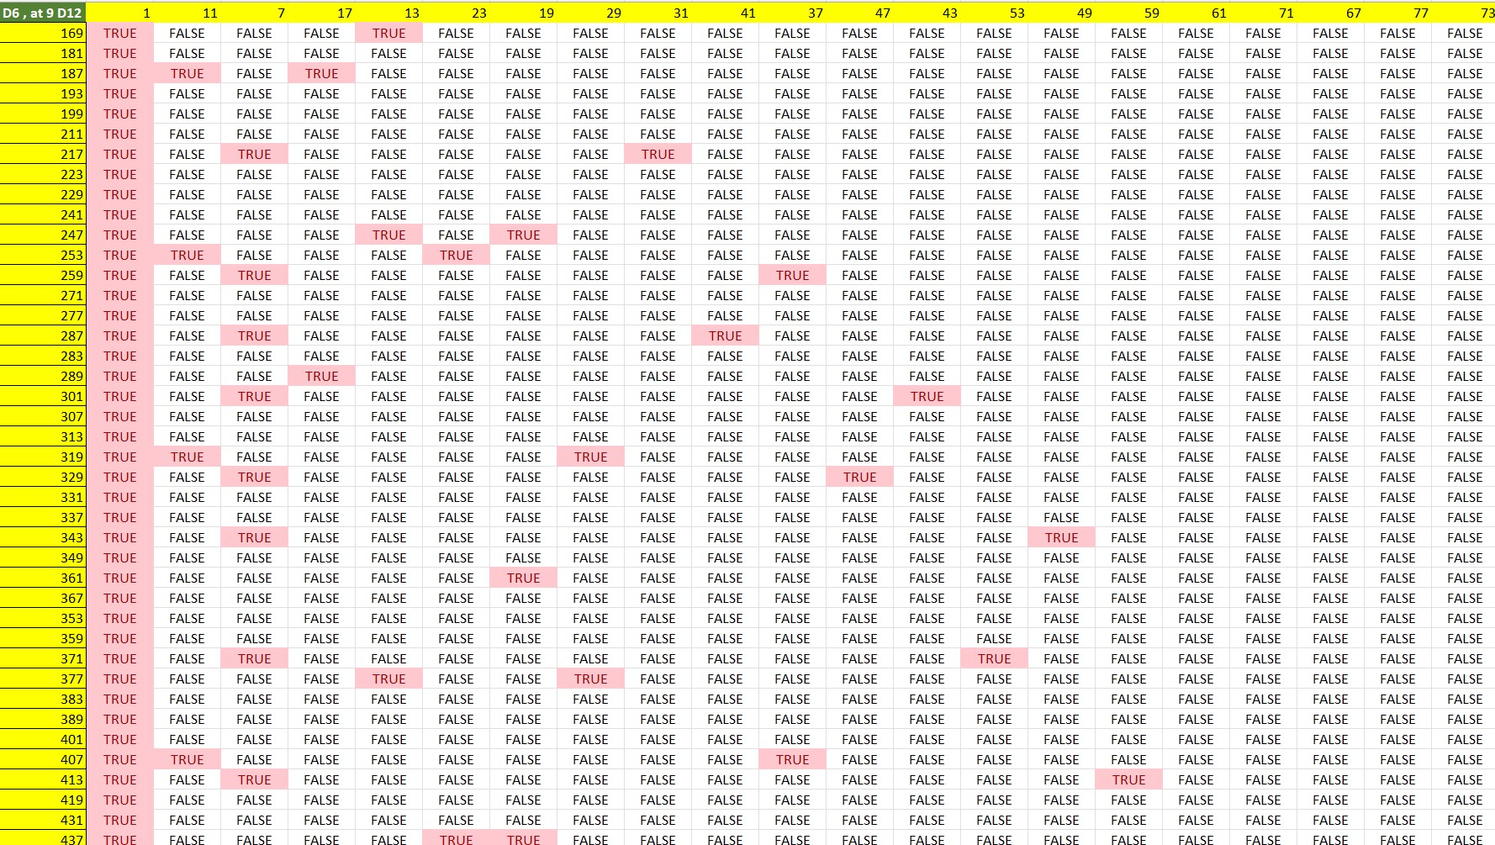
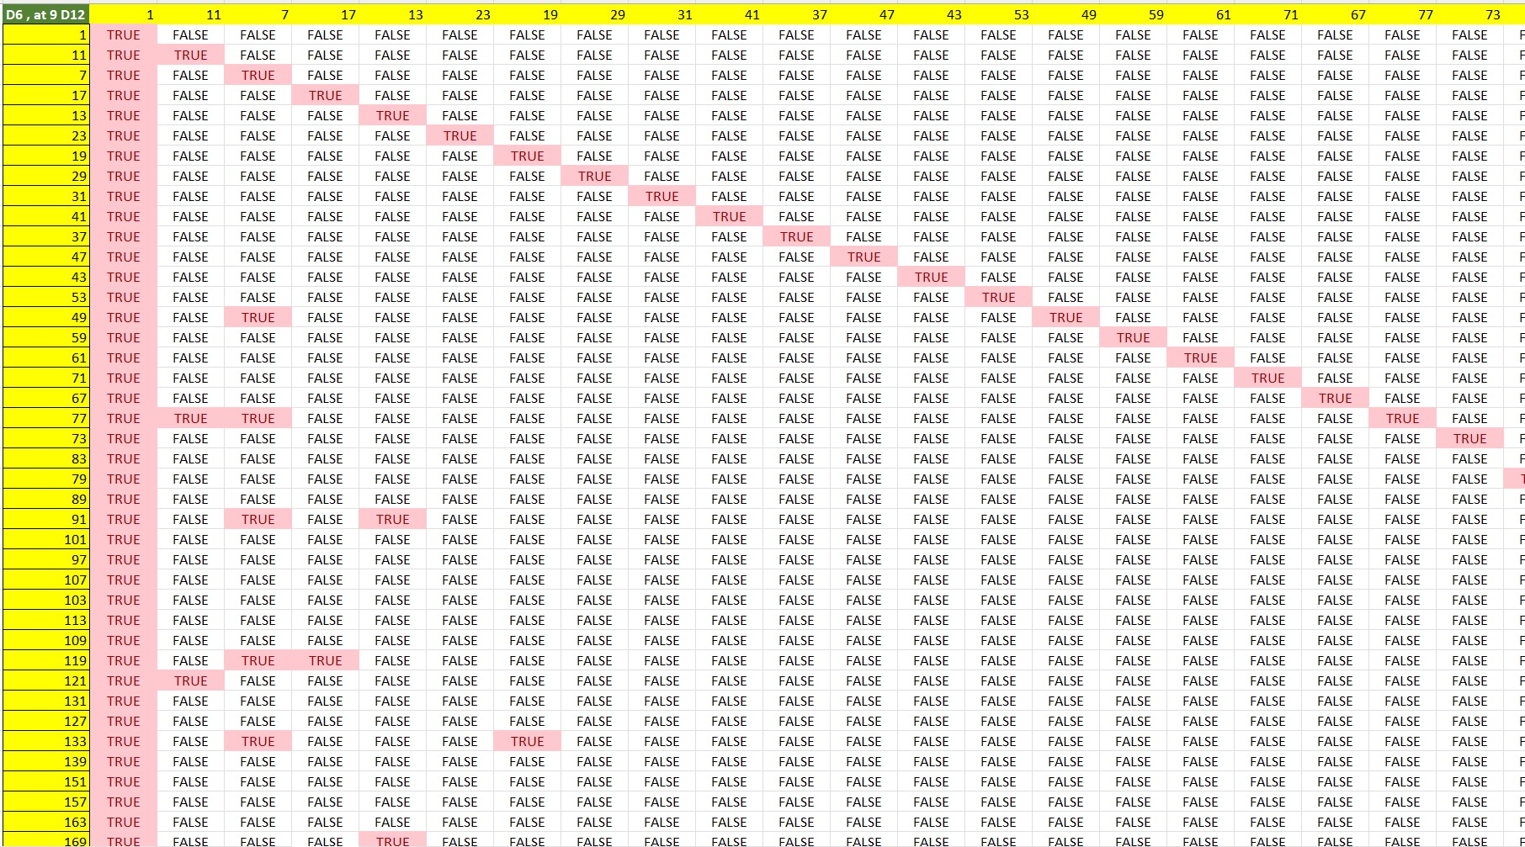
Figure 6. Factorization and prime number data frame matrix.
Figure 7. Factorization and prime number data frame matrix.

This is the full matrix for factoring and finding the primes but in order to find all primes less than number [N] we do not need to use modules for all numbers in the list we only need to construct smaller matrix from [N rows and
M columns] where M in Branch (1) list and <= sqrt(n).

Given number N. Get list of prime number up until number N.
- Initiate Branch (1) & Branch (2) (two sequence lists (+6, +12, +10)) up until number <= given number N
1- Construct data frame matrix M of [A, B], where A (row names) = Branch lists, and B (columns name) <= sqrt(N) and B (column name) in Branches list.
2- Calculate (row name) mod (column name) on data frame M.
3- filter the data frame matrix for rows that only have exactly one True value.
4- return filtered Data frame Matrix M.

And as our branch list is limited list and its length approximate N/4.
And we use matrix operations, and we only need to loop on column names to apply Mod function, then our algorithm <=

Conclusion
First we showed a primary sequence list of natural numbers that we can use to get a distinct list of prime numbers, and we showed how these numbers are the primary list of prime numbers. Then showed how this distribution can be used to get next most likely prime number based on the described distribution. And how we introduced batch algorithm to get list of prime numbers up until natural number [N].

References

[1] A. O. L. Atkin, D. J. Bernstein, prime sieves using binary quadratic forms, mathematics of computation volume 73, number 246, pages 1023–1030 s 0025-5718(03)01501-1 article electronically published on December 19, 2003.

[2] S. Soltan, Step Pyramid Distribution for Prime Numbers, Journal of Mathematics Research

Vol. 14, No. 1 (2022), DOI:10.5539/jmr.v14n1p55

Copyrights
Copyright for this article is retained by the author(s), with first publication rights granted to the journal.
This is an open-access article distributed under the terms and conditions of the Creative Commons Attribution license (http://creativecommons.org/licenses/by/3.0/).

